Objectives:

* Using float
* Using the Round function
* **There are 5 challenge exercises, each worth 20%**

Please submit this document for grading when completed… Please work in-groups.

1. The float returns a floating-point number from a number to a string.

Sample output

1. Getting the remainder operator

Sample output

1. Delete the extra / and run the program again, notice that the results give us a fractional output.

1. Getting the future value

Sample output

1. **Challenge** **Exercise** **#1**: modify #4 (the future value program) so it does NOT display any fractional output.

**#1 print screen the code with the output below here.**

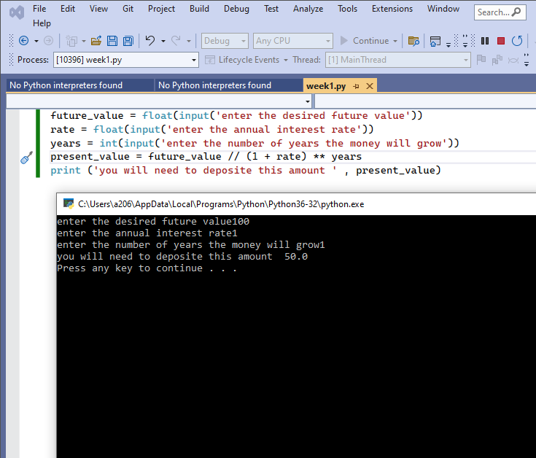

1. Rounding floating point numbers.

Sample output

1. **Challenge** **Exercise** **#2:** Turn to page 114 and complete the Sales Prediction program

**#2 print screen the code with the output below here.**

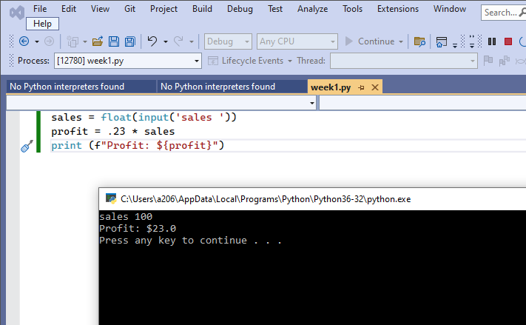

1. **Challenge** **Exercise** **#3:** Turn to page 115 and complete the Tip, Tax and Total program

**#3 print screen the code with the output below here.**

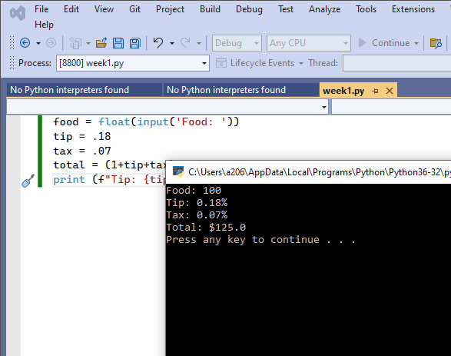

1. **Challenge** **Exercise** **#4:** Turn to page 115 and complete the Male and Female Percentages program.

**#4 print screen the code with the output below here.**

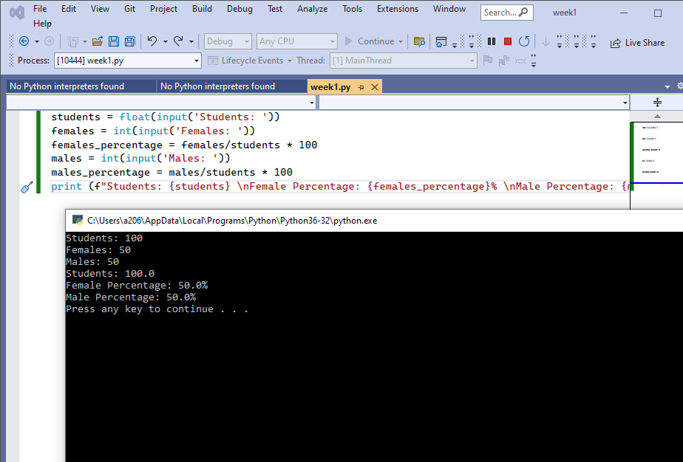

1. **Challenge** **Exercise** **#5:** Turn to page 115 and complete the Stock Transaction program.

**#5 print screen the code with the output below here.**

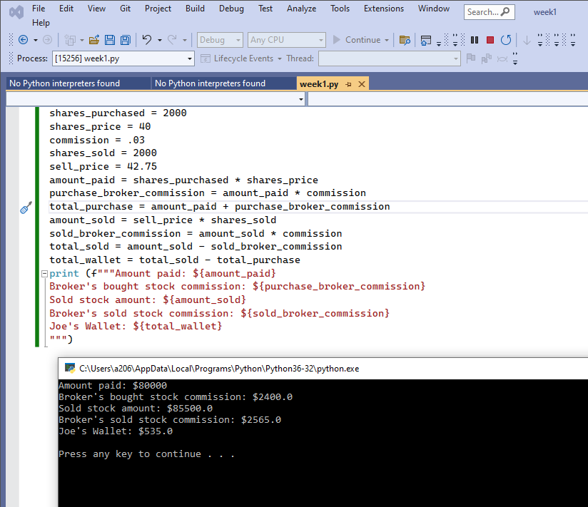

**Submit this document to Module 1 Class Exercise**